Table of Contents
Table of Contents 1
1. Rationale 2
1(a) Problem Description 2
1(b) Background 2
1(c) Community Impact 2
1(d) Proposed Solution 3
1(e) Computational Thinking Process 3
1(f) Algorithm Design 3
1(g) SDG Alignment 4
1(h) Open Source Justification 4
1(i) Digital Public Goods Justification 4
2. Algorithm 6
3. Pseudocode 7
3.1 Variables, Constants and Data Types 7
3.2 Full Pseudocode 7
4. Flowcharts 11
5. Functional Modules 16
5.1 How the Logical Design Requirements Are Met 17
6. Expected Outputs 18
6.1 Scenario 1: Four reports in August (rainy season) 18
6.2 Scenario 2: Same Kroo Bay report in February (dry season) 18
6.3 Scenario 3: Invalid input 18
7. GitHub Evidence 20
7.1 Repository Structure 20
7.2 Git Commit History 20
7.3 Repository Screenshot 20
8. References 21

1. Rationale

1(a) Problem Description
Freetown, the capital of Sierra Leone, produces more solid waste than its collection services can remove. Concern Worldwide estimates that only 21% of Freetown's waste is properly collected and disposed of, leaving roughly 550 tons per day to be burned or dumped in streets, waterways and illegal dumpsites. Waste left in drains blocks the flow of rainwater, which causes flooding and standing water during the rainy season. Freetown City Council itself identifies sanitation, including solid waste, as probably the city's biggest challenge, and links waste in drains to flooding and the spread of malaria and cholera.
One part of this problem can be solved with better logic rather than more money: deciding which waste piles to collect first. Trucks and crews are limited. Without a clear and fair way to rank reported sites, a dangerous pile blocking a drain in Kroo Bay can wait as long as a small pile on a quiet street. This project designs Waste Watch SL, a system that turns community reports into a ranked collection list.

Who is affected
- Residents of informal and coastal settlements (for example Kroo Bay, Susan's Bay and Kissy), who live closest to blocked drains and dumpsites.
- Children, traders and patients at schools, markets and health centres near uncollected waste.
- Freetown City Council (FCC) and ward level waste collectors, who must plan routes with limited trucks.

Why the problem exists
- Collection capacity is far below the volume of waste produced.
- Only two authorised dumpsites serve the city, Kingtom and Granville Brook, and both are poorly controlled.
- There is no simple, shared method for residents to report waste and for officers to rank reports objectively.
- Plastic water sachets and bottles clog drains, and the problem worsens every rainy season.

1(b) Background
Waste and flooding have a long history in Freetown. The 2017 flash floods and landslides and the August 2019 citywide flooding both showed how waste in drainage systems worsens disasters. Flooding also raises the risk of waterborne disease; cholera has remained a risk since the 2012 outbreak. The Freetown City Council's "Transform Freetown" plan aims to safely collect and manage 60% of the city's waste. Reaching that target requires using existing trucks and crews well, and that depends on good information about where waste is and how dangerous it is.

1(c) Community Impact
If the most dangerous sites are cleared first, fewer drains are blocked when the rains come, fewer people are exposed to waste near schools, markets and clinics, and hazardous medical or chemical waste is removed quickly and safely. The daily summary also gives the council evidence to plan resources and to report progress to residents. The main beneficiaries are residents of flood prone and low-income communities, learners, traders, health workers and the council's waste teams.

1(d) Proposed Solution
Waste Watch SL is a logical design for a waste reporting and collection priority system. A community volunteer, ward officer or resident reports a waste pile. Reports could come through a short SMS/USSD code that works on basic phones or through a simple mobile form. For each report the system:
- collects six facts: waste type, pile size, days left uncollected, whether it is near a drain, whether it is near a school, market or health centre, and the current month
- calculates a priority score from 0 to 13
- classifies the report as URGENT, HIGH or ROUTINE (hazardous waste is always URGENT);
- recommends an action, such as collection within 24 hours, recycling plastics or composting organic waste
- at the end of the day, produces a summary for the council showing counts, percentages, average days uncollected and the number of truck trips needed.

1(e) Computational Thinking Process
Stage | How it was applied in WasteWatch SL
Decomposition | The big problem ("Freetown's waste is not collected well") was broken into smaller parts: (1) collect a report, (2) check the input is valid, (3) score the danger, (4) classify the priority, (5) recommend an action, (6) summarise all reports for planning.
Pattern recognition | Dangerous waste sites share common features: they have been left a long time, they are large, they are near drains, they are near crowded public places, they contain hazardous material, and the danger rises in the rainy season (May–October).
Abstraction | Details that do not change the decision (colour, smell, exact GPS point, reporter's name) were left out. Only the six factors that affect risk were kept, and pile size was simplified into three codes (Small, Medium, Large).
Algorithm design | The factors were turned into clear rules with points (for example, near a drain = +2 points) and thresholds (8 or more = URGENT), written as step-by-step instructions, pseudocode and flowcharts.

1(f) Algorithm Design
The design uses a points-based scoring method because it is easy to explain to community members and council staff, easy to change later and treats every report the same way. The table below shows the scoring rules :
Factor | Condition | Points
Days uncollected | 7 or more days / 3–6 days / 0–2 days | +3 / +2 / 0
Pile size | Large / Medium / Small | +2 / +1 / 0
Near a drain or stream | Yes | +2
Near a school, market or health centre | Yes | +2
Waste type | Hazardous (medical or chemical) | +3
Rainy season AND near a drain | Both true (Boolean AND) | +1
Maximum possible score |  | 13

Score | Priority | Action
8 – 13 (or any hazardous waste) | URGENT | Send a truck within 24 hours and alert the ward councillor
4 – 7 | HIGH | Collect within 3 days
0 – 3 | ROUTINE | Add to the next weekly collection round

1(g) SDG Alignment
- SDG 11 – Sustainable Cities and Communities (main goal). Target 11.6 calls for reducing the environmental impact of cities, with attention to municipal waste management. Waste Watch SL directly improves how Freetown collects its waste.
- SDG 3 – Good Health and Well being. Target 3.3 includes fighting water-borne diseases. Clearing waste near drains and public places reduces breeding sites for mosquitoes and the spread of cholera.
- SDG 6 – Clean Water and Sanitation. Target 6.3 aims to improve water quality by reducing pollution and dumping.
- SDG 12 – Responsible Consumption and Production. Target 12.5 aims to reduce waste through recycling and reuse. The system flags plastics for recycling and organic waste for composting.

1(h) Open Source Justification
Waste Watch SL should be released as open source software under an OSI-approved licence such as the MIT licence, for these reasons:
- Low cost: councils and NGOs in Sierra Leone can use it without paying licence fees.
- No vendor lock-in: open source gives users more control and independence (Digital Public Goods Alliance, 2020), so the council is not tied to one company.
- Trust and transparency: anyone can inspect how the priority score is calculated, so residents can see that the ranking is fair.
- Local adaptation: other district councils (for example Bo, Kenema or Makeni) can change the constants, such as rainy-season months or truck capacity, to fit their needs.
- Community contributions: Sierra Leonean students, developers and NGOs can translate it into Krio, add SMS/USSD reporting, add maps, or fix errors through GitHub.

1(i) Digital Public Goods Justification
A Digital Public Good (DPG) is open source software, data, AI models, standards or content that follows privacy laws and best practice, does no harm, and helps achieve the SDGs. Sierra Leone is a co-founder of the Digital Public Goods Alliance, together with Norway, UNICEF and iSPIRT. Waste Watch SL could become a DPG by meeting the Alliance's standard:
- SDG relevance: clearly linked to SDGs 11, 3, 6 and 12.
- Open licence: released under the OSI-approved MIT licence.
- Documentation: the algorithm, pseudocode, flowcharts and README in the GitHub repository document its functional requirements.
- Privacy and do no harm: reports store a location and the type of waste, not the reporter's personal details.
- Platform independence: the design does not depend on any paid or closed technology.
As a DPG, it would be accessible (works through basic phones and community volunteers), open (anyone can see and reuse the logic) and of public benefit (cleaner, safer and healthier communities). Long term sustainability comes from council ownership, community volunteers and youth waste groups who report and collect, and an open community of developers who maintain the code.

2. Algorithm
- Start.
- Set the constants: rainy season = months 5 to 10; warning = 3 days; critical = 7 days; URGENT score = 8; HIGH score = 4; truck capacity = 10 load units.
- Input the current month. While it is not between 1 and 12, display an error and input it again.
- Set rainySeason to TRUE if the month is from 5 to 10, otherwise FALSE.
- Input the number of reports. While it is less than 1, display an error and input it again.
- Set the counters urgentCount, highCount, routineCount, total Units and total Days to 0.
- For each report (i = 1 to numReports), repeat steps 8 to 15.
- Input the report ID and community name.
- Input the waste type (1 Household, 2 Plastic, 3 Market/Organic, 4 Hazardous), repeating until valid.
- Input the pile size (1 Small, 2 Medium, 3 Large), repeating until valid.
- Input the days uncollected (0–60), repeating until valid.
- Input Y/N for "near a drain" and "near a school, market or health centre", repeating until Y or N is entered.
- Calculate the priority score using the scoring rules in Section 1(f).
- Classify the priority: hazardous waste → URGENT; otherwise score ≥ 8 → URGENT, score ≥ 4 → HIGH, else ROUTINE.
- Choose the recommended action, display the report, add 1 to the matching counter, and add the load units (Small 1, Medium 3, Large 8) and the days uncollected to the totals.
- After the loop, calculate truck trips = totalUnits ÷ 10 rounded up, and average days = total Days ÷ numReports.
- Display the daily summary with counts and percentages. If urgentCount > 0, display a warning.
- Stop.

3. Pseudocode

3.1 Variables, Constants and Data Types
Name | Kind | Data type | Purpose
RAINY_START, RAINY_END | Constant | Integer | First and last month of the rainy season (5 and 10)
WARNING_DAYS, CRITICAL_DAYS | Constant | Integer | Days uncollected that trigger points (3 and 7)
URGENT_SCORE, HIGH_SCORE | Constant | Integer | Score thresholds (8 and 4)
SMALL/MEDIUM/LARGE_UNITS | Constant | Integer | Load units per pile size (1, 3, 8)
TRUCK_CAPACITY | Constant | Integer | Load units one truck carries per trip (10)
month, numReports | Variable | Integer | Current month; number of reports today
reportID, community | Variable | String | Identifies each report and its location
wasteType, volumeCode | Variable | Integer | Coded menu choices (1–4 and 1–3)
daysUncollected | Variable | Integer | How long the pile has been left
nearDrain, nearPublicPlace, rainySeason | Variable | Boolean | TRUE/FALSE conditions used in decisions
score | Variable | Integer | Priority score from 0 to 13
priority, action | Variable | String | Result of classification and recommendation
urgentCount, highCount, routineCount, total Units, total Days | Variable | Integer | Running totals (accumulators) for the summary
trucks Needed / avgDays | Variable | Integer / Real | Calculated in the daily summary

3.2 Full Pseudocode
// ---------------------------------------------------------------
// CONSTANTS (fixed values that never change while the system runs)
// ---------------------------------------------------------------
CONSTANT RAINY_START = 5 // May
CONSTANT RAINY_END = 10 // October
CONSTANT WARNING_DAYS = 3 // days uncollected before a warning
CONSTANT CRITICAL_DAYS = 7 // days uncollected that are critical
CONSTANT URGENT_SCORE = 8 // total points for URGENT priority
CONSTANT HIGH_SCORE = 4 // total points for HIGH priority
CONSTANT SMALL_UNITS = 1 // load units for a small pile (a few bags)
CONSTANT MEDIUM_UNITS = 3 // load units for a medium pile (cart load)
CONSTANT LARGE_UNITS = 8 // load units for a large pile (truck load)
CONSTANT TRUCK_CAPACITY = 10 // load units one truck can carry per trip

// Waste type codes: 1 = Household, 2 = Plastic, 3 = Market/Organic, 4 = Hazardous
// Volume codes : 1 = Small, 2 = Medium, 3 = Large

// ---------------------------------------------------------------
// MODULE 1: MAIN PROGRAM (controls the whole system)
// ---------------------------------------------------------------
MODULE Main()
DECLARE month, numReports AS Integer
DECLARE rainySeason AS Boolean
DECLARE urgentCount, highCount, routineCount AS Integer = 0
DECLARE totalUnits, totalDays AS Integer = 0

DECLARE reportID, community AS String
DECLARE wasteType, volumeCode, daysUncollected AS Integer
DECLARE nearDrain, nearPublicPlace AS Boolean
DECLARE score AS Integer
DECLARE priority, action AS String

DISPLAY "=== WASTEWATCH SL: WASTE COLLECTION PRIORITY SYSTEM ==="
month = GetValidInteger("Enter current month (1-12): ", 1, 12)
rainySeason = IsRainySeason(month)
numReports = GetValidInteger("How many waste reports today? ", 1, 1000)

// REPETITION: process every report one by one
FOR i = 1 TO numReports
DISPLAY "--- Report ", i, " of ", numReports, " ---"
INPUT reportID, community
wasteType = GetValidInteger("Waste type (1=Household 2=Plastic 3=Market 4=Hazardous): ", 1, 4)
volumeCode = GetValidInteger("Pile size (1=Small 2=Medium 3=Large): ", 1, 3)
daysUncollected = GetValidInteger("Days left uncollected: ", 0, 60)
nearDrain = GetYesNo("Is it in or near a drain/stream? (Y/N): ")
nearPublicPlace = GetYesNo("Is it near a school, market or health centre? (Y/N): ")

score = CalculatePriorityScore(wasteType, volumeCode, daysUncollected,
nearDrain, nearPublicPlace, rainySeason)
priority = classify Priority(score, wasteType)
action = RecommendAction(priority, wasteType)

CALL Display Report(reportID, community, score, priority, action)

// DECISION: count each priority level
IF priority = "URGENT" THEN
urgentCount = urgentCount + 1
ELSE IF priority = "HIGH" THEN
high Count = highCount + 1
ELSE
routineCount = routineCount + 1
END IF

totalUnits = totalUnits + GetLoadUnits(volumeCode)
totalDays = totalDays + daysUncollected
END FOR

CALL GenerateDailySummary(numReports, urgentCount, highCount, routineCount,
totalUnits, totalDays)
END MODULE

// ---------------------------------------------------------------
// MODULE 2: INPUT VALIDATION (repeats until a valid value is typed)
// ---------------------------------------------------------------
FUNCTION GetValidInteger(prompt, minValue, maxValue) RETURNS Integer
DECLARE value AS Integer
DISPLAY prompt
INPUT value
WHILE value < minValue OR value > maxValue
DISPLAY "Error: enter a number from ", minValue, " to ", maxValue, "."
INPUT value
END WHILE
RETURN value
END FUNCTION

FUNCTION GetYesNo(prompt) RETURNS Boolean
DECLARE answer AS String
DISPLAY prompt
INPUT answer
WHILE answer <> "Y" AND answer <> "N"
DISPLAY "Error: please type Y or N."
INPUT answer
END WHILE
RETURN (answer = "Y")
END FUNCTION

// ---------------------------------------------------------------
// MODULE 3: SEASON CHECK (Boolean logic)
// ---------------------------------------------------------------
FUNCTION IsRainySeason(month) RETURNS Boolean
RETURN (month >= RAINY_START AND month <= RAINY_END)
END FUNCTION

// ---------------------------------------------------------------
// MODULE 4: PRIORITY SCORE (adds points for each danger sign)
// ---------------------------------------------------------------
FUNCTION CalculatePriorityScore(wasteType, volumeCode, daysUncollected,
nearDrain, nearPublicPlace, rainySeason) RETURNS Integer
DECLARE score AS Integer = 0

// How long it has been left
IF daysUncollected >= CRITICAL_DAYS THEN
score = score + 3
ELSE IF days Uncollected >= WARNING_DAYS THEN
score = score + 2
END IF

// How big the pile is
IF volumeCode = 3 THEN
score = score + 2
ELSE IF volumeCode = 2 THEN
score = score + 1
END IF

// Where it is
IF nearDrain = TRUE THEN
score = score + 2 // can block drains and cause flooding
END IF
IF nearPublicPlace = TRUE THEN
score = score + 2 // many people exposed to disease
END IF

// What it is
IF wasteType = 4 THEN
score = score + 3 // hazardous: medical or chemical
END IF

// Combined condition (Boolean AND)
IF rainy Season = TRUE AND near Drain = TRUE THEN
score = score + 1 // extra flood risk in the rains
END IF

RETURN score // lowest 0, highest 13
END FUNCTION

// ---------------------------------------------------------------
// MODULE 5: CLASSIFY PRIORITY
// ---------------------------------------------------------------
FUNCTION ClassifyPriority(score, wasteType) RETURNS String
IF wasteType = 4 THEN
RETURN "URGENT" // safety rule: hazardous is always urgent
ELSE IF score >= URGENT_SCORE THEN
RETURN "URGENT"
ELSE IF score >= HIGH_SCORE THEN
RETURN "HIGH"
ELSE
RETURN "ROUTINE"
END IF
END FUNCTION

// ---------------------------------------------------------------
// MODULE 6: RECOMMEND ACTION
// ---------------------------------------------------------------
FUNCTION recommend Action(priority, wasteType) RETURNS String
DECLARE action AS String

SELECT CASE priority
CASE "URGENT":
action = "Send truck within 24 hours and alert ward councillor."
CASE "HIGH":
action = "Collect within 3 days."
CASE "ROUTINE":
action = "Add to next weekly collection round."
END SELECT

// Extra advice based on waste type (nested decision)
IF wasteType = 2 THEN
action = action + " Separate plastics for recycling."
ELSE IF wasteType = 3 THEN
action = action + " Send organic waste for composting."
ELSE IF wasteType = 4 THEN
action = action + " Crew must wear protective gear."
END IF

RETURN action
END FUNCTION

// ---------------------------------------------------------------
// MODULE 7: LOAD UNITS (used to plan trucks)
// ---------------------------------------------------------------
FUNCTION GetLoadUnits(volumeCode) RETURNS Integer
IF volumeCode = 1 THEN
RETURN SMALL_UNITS
ELSE IF volumeCode = 2 THEN
RETURN MEDIUM_UNITS
ELSE
RETURN LARGE_UNITS
END IF
END FUNCTION

// ---------------------------------------------------------------
// MODULE 8: OUTPUT - ONE REPORT
// ---------------------------------------------------------------
MODULE DisplayReport(reportID, community, score, priority, action)
DISPLAY "Report : ", reportID, " - ", community
DISPLAY "Score : ", score, " / 13"
DISPLAY "Priority : ", priority
DISPLAY "Action : ", action
END MODULE

// ---------------------------------------------------------------
// MODULE 9: OUTPUT - DAILY SUMMARY FOR THE COUNCIL
// ---------------------------------------------------------------
MODULE GenerateDailySummary(numReports, urgentCount, highCount, routineCount,
totalUnits, totalDays)
DECLARE trucksNeeded AS Integer
DECLARE avgDays AS Real

trucksNeeded = CEILING(totalUnits / TRUCK_CAPACITY) // round up
avgDays = totalDays / numReports

DISPLAY "=== DAILY SUMMARY ==="
DISPLAY "Reports received : ", numReports
DISPLAY "URGENT : ", urgentCount, " (", ROUND(urgentCount / numReports * 100, 1), "%)"
DISPLAY "HIGH : ", highCount, " (", ROUND(highCount / numReports * 100, 1), "%)"
DISPLAY "ROUTINE : ", routineCount, " (", ROUND(routineCount / numReports * 100, 1), "%)"
DISPLAY "Total load units : ", totalUnits
DISPLAY "Truck trips needed : ", trucksNeeded
DISPLAY "Avg days uncollected : ", ROUND(avgDays, 1)

IF urgentCount > 0 THEN
DISPLAY "WARNING: ", urgentCount, " site(s) need collection within 24 hours."
END IF
END MODULE

4. Flowcharts
These flowcharts were created with Mermaid, they use standard symbols: oval = start/stop, parallelogram = input/output, rectangle = process, diamond = decision, double-sided rectangle = call to a module, circle = connector.
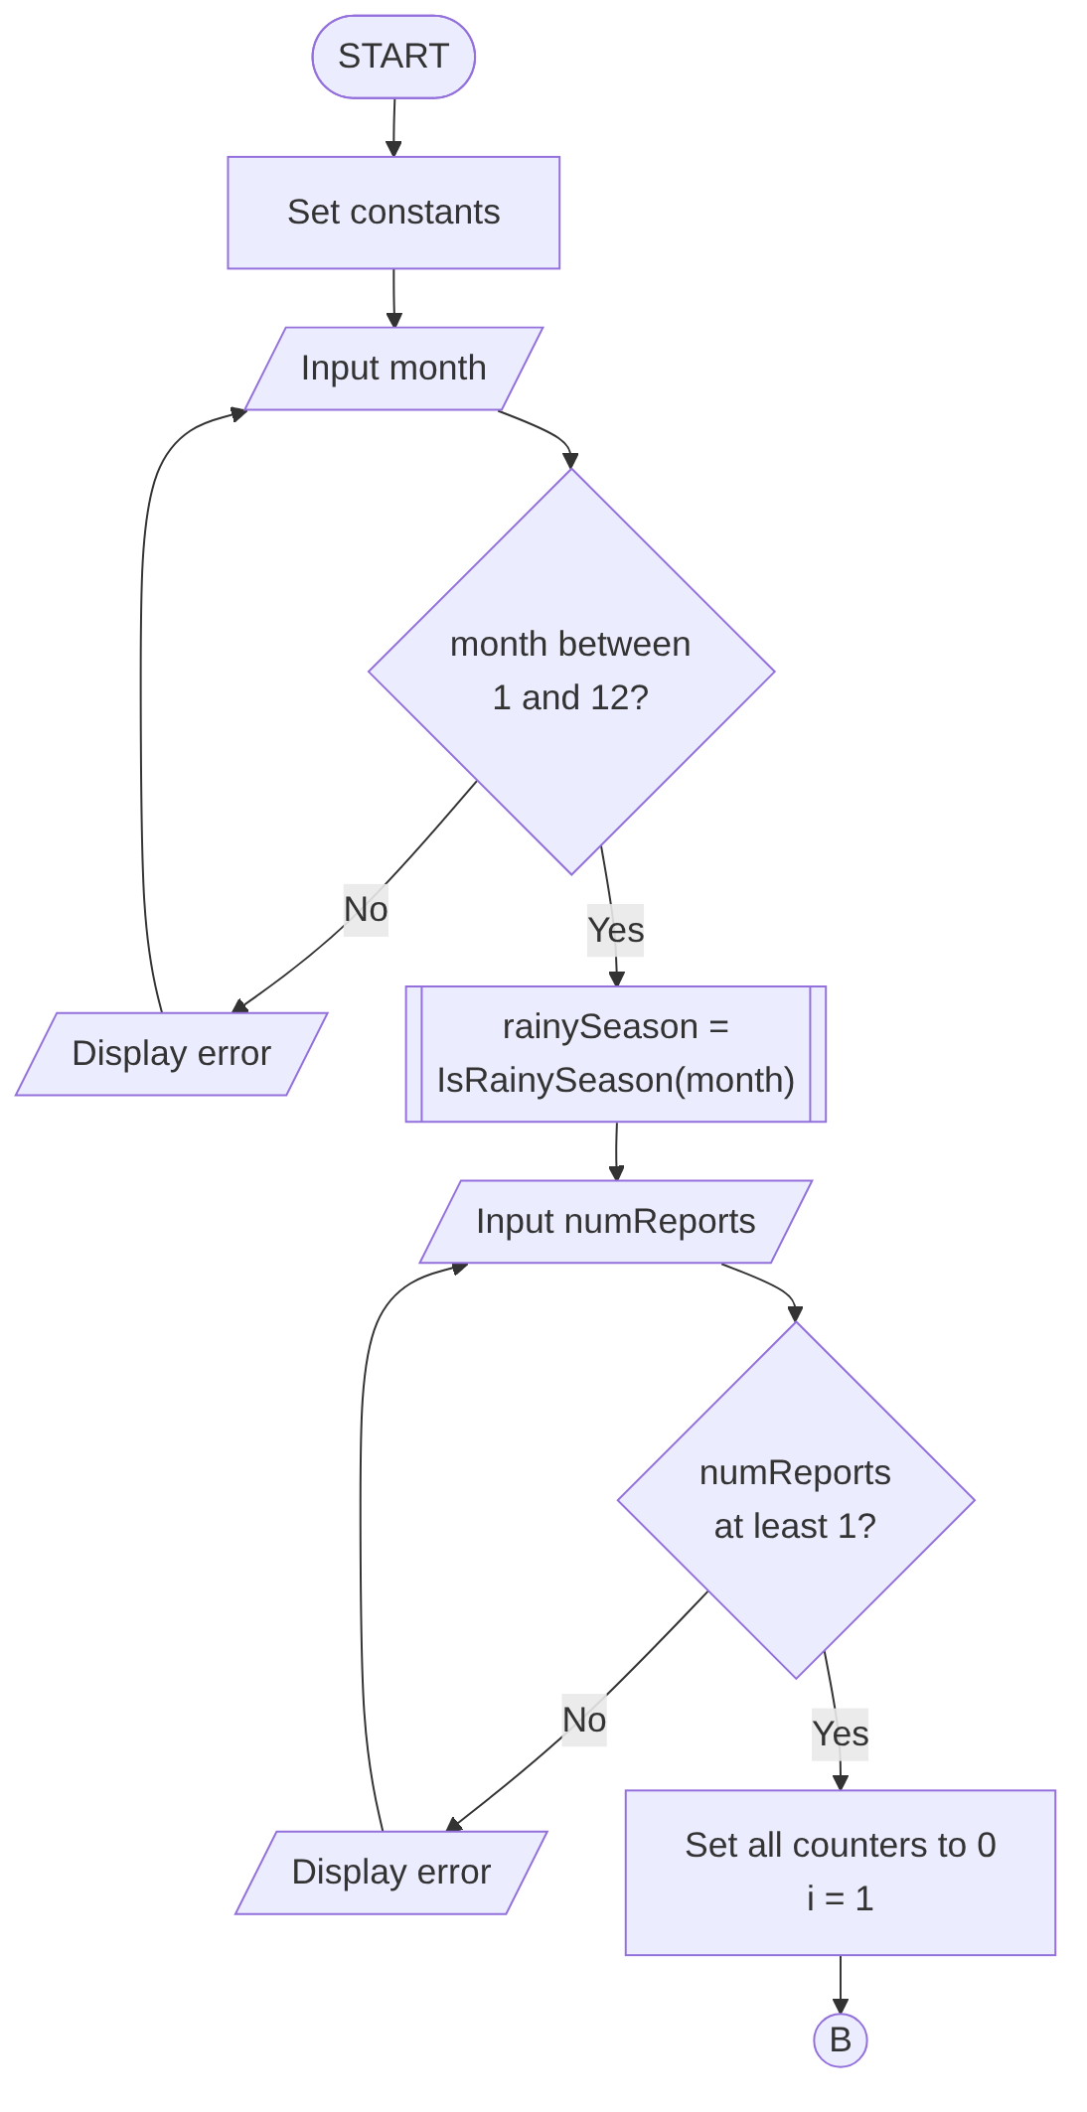
Figure 1: Main program – Part 1 (set-up and input validation loops)

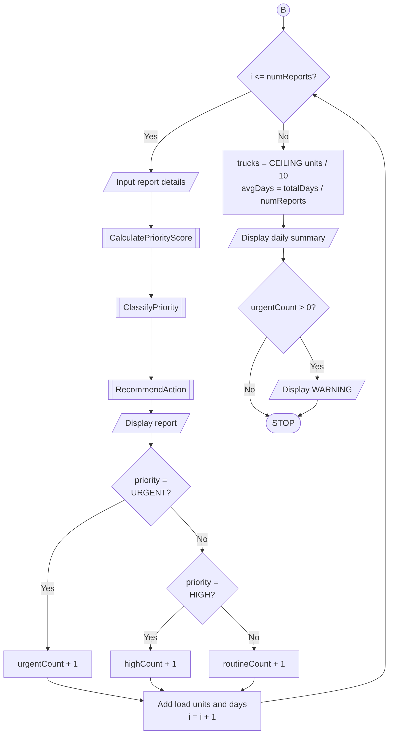
Figure 2: Main program – Part 2 (repetition over all reports and daily summary)

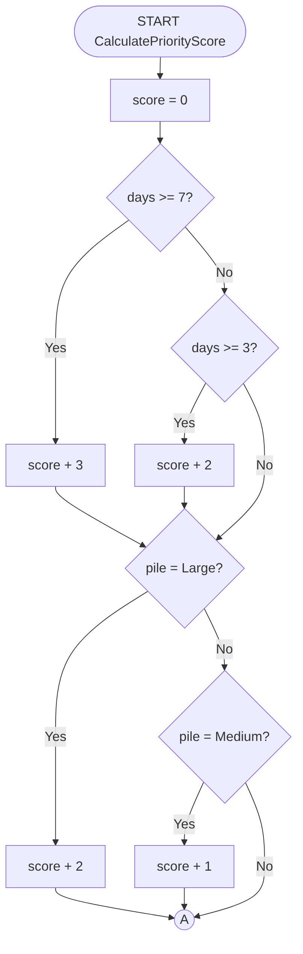
Figure 3: CalculatePriorityScore – Part 1 (days uncollected and pile size)

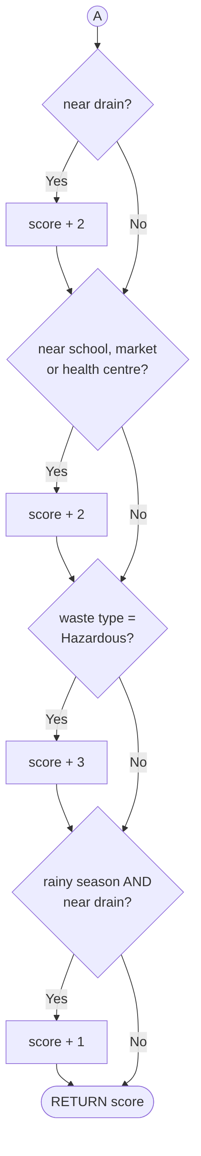
Figure 4: CalculatePriorityScore – Part 2 (location, hazard and rainy season)

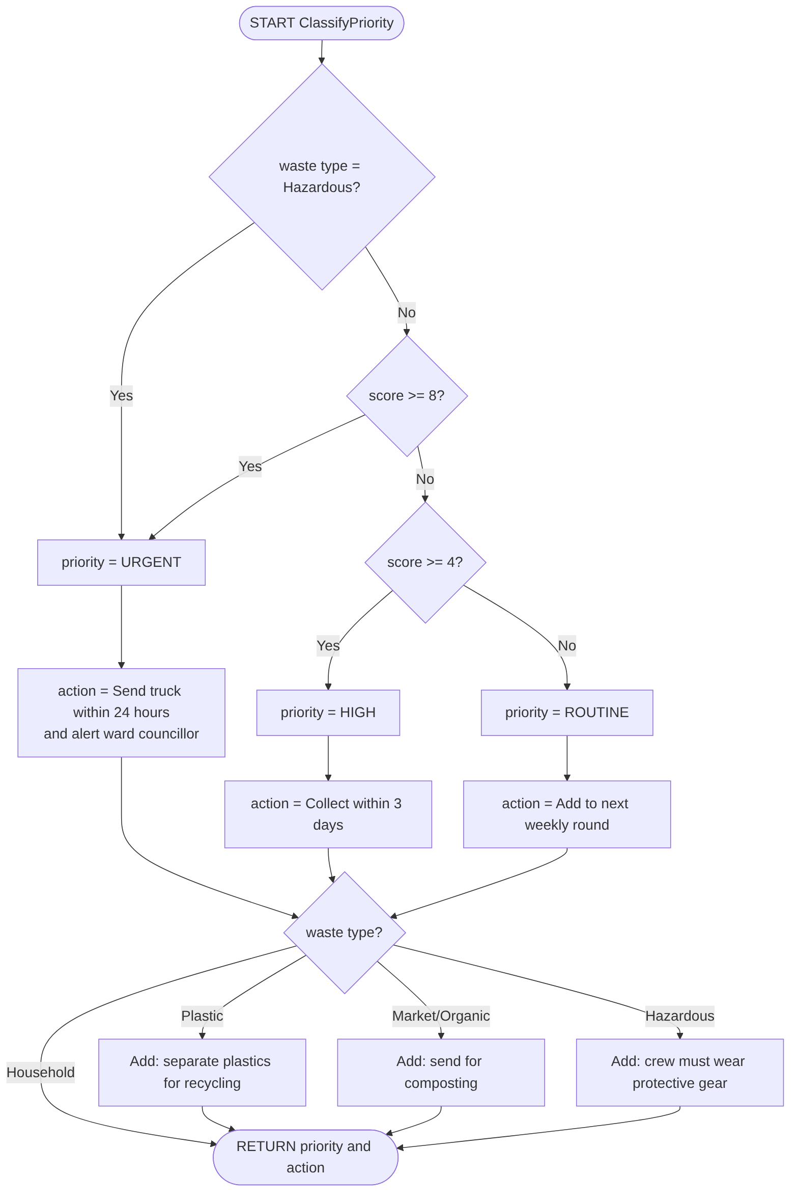
Figure 5: ClassifyPriority and RecommendAction

5. Functional Modules
The system is divided into nine modules. Each module does one job, which makes the design easier to understand, test and change (modular design).
# | Module / Function | Type | Input (parameters) | Output | Purpose
1 | Main | Module | – | – | Controls the program and the main FOR loop
2 | GetValidInteger, GetYesNo | Functions | prompt, min, max | Integer / Boolean | WHILE loops that repeat until input is valid
3 | IsRainySeason | Function | month | Boolean | Checks month ≥ 5 AND month ≤ 10
4 | CalculatePriorityScore | Function | wasteType, volume Code, days, near Drain, nearPublicPlace, rainy Season | Integer (0–13) | Adds points for each danger sign
5 | Classify Priority | Function | score, wasteType | String | Returns URGENT, HIGH or ROUTINE
6 | recommendation | Function | priority, wasteType | String | Returns collection time and recycling/safety advice
7 | GetLoadUnits | Function | volumeCode | Integer | Converts pile size into load units
8 | Display Report | Module | reportID, community, score, priority, action | Screen output | Shows the result for one report
9 | GenerateDailySummary | Module | counts and totals | Screen output | Shows totals, percentages and truck trips

5.1 How the Logical Design Requirements were met
Requirement | Where it appears in Waste Watch SL
Input | Month, number of reports, and six details for each report
Processing | Priority score calculation, classification, load units, truck trips, averages and percentages
Output | Individual report (score, priority, action) and daily summary with warning
Decision structures | IF / ELSE IF / ELSE in scoring and classification; SELECT CASE in Recommend Action; nested IF for waste type advice
Boolean logic | AND (rainy season AND near drain; month ≥ 5 AND month ≤ 10), OR (value < min OR value > max)
Repetition structures | FOR loop over every report; while loops for input validation
Modules and functions | Nine modules; functions with parameters and RETURN values
Variables, constants, data types | (Integer, Real, String, Boolean, named constants)
Problem decomposition

6. Expected Outputs
The following sample scenarios show what the system would output. All scores were checked by hand against the scoring rules.

6.1 Scenario 1: Four reports in August (rainy season)
ID | Community | Waste type | Size | Days | Drain | Public place | Score | Priority
R001 | Kroo Bay | Plastic | Large | 9 | Y | N | 3+2+2+1 = 8 | URGENT
R002 | Lumley Market | Market/Organic | Medium | 4 | N | Y | 2+1+2 = 5 | HIGH
R003 | Wilberforce | Household | Small | 1 | N | N | 0 | ROUTINE
R004 | Kissy (near health centre) | Hazardous | Small | 2 | N | Y | 2+3 = 5 | URGENT*

*R004 scores only 5, but the safety rule makes all hazardous waste URGENT.
=== WASTEWATCH SL: WASTE COLLECTION PRIORITY SYSTEM ===
Enter current month (1-12): 8
How many waste reports today? 4
--- Report 1 of 4 ---
Report : R001 - Kroo Bay
Score : 8 / 13
Priority : URGENT
Action : Send truck within 24 hours and alert ward councillor.
Separate plastics for recycling.
--- Report 2 of 4 ---
Report : R002 - Lumley Market
Score : 5 / 13
Priority : HIGH
Action : Collect within 3 days. Send organic waste for composting.
--- Report 3 of 4 ---
Report : R003 - Wilberforce
Score : 0 / 13
Priority : ROUTINE
Action : Add to next weekly collection round.
--- Report 4 of 4 ---
Report : R004 - Kissy (near health centre)
Score : 5 / 13
Priority : URGENT
Action : Send truck within 24 hours and alert ward councillor.
Crew must wear protective gear.

=== DAILY SUMMARY ===
Reports received : 4
URGENT : 2 (50.0%)
HIGH : 1 (25.0%)
ROUTINE : 1 (25.0%)
Total load units : 13 (8 + 3 + 1 + 1)
Truck trips needed : 2 (13 / 10 = 1.3, rounded up)
Avg days uncollected : 4.0 ((9 + 4 + 1 + 2) / 4)
WARNING: 2 site(s) need collection within 24 hours.

6.2 Scenario 2: Same Kroo Bay report in February (dry season)
If report R001 is entered in month 2, IsRainySeason returns FALSE, so the condition "rainy season AND near drain" is FALSE and the extra point is not added. The score becomes 3 + 2 + 2 = 7, so the priority changes from URGENT to HIGH ("Collect within 3 days"). This shows the Boolean AND logic working: the same pile is treated as more dangerous in the rainy season, when blocked drains cause floods.

6.3 Scenario 3: Invalid input
Enter current month (1-12): 13
Error: enter a number from 1 to 12.
8
Waste type (1=Household 2=Plastic 3=Market 4=Hazardous): 6
Error: enter a number from 1 to 4.
2
Days left uncollected: -2
Error: enter a number from 0 to 60.
9
Is it in or near a drain/stream? (Y/N): maybe
Error: please type Y or N.
Y
The WHILE loops keep asking until valid data is entered, so wrong values never reach the calculations.

7. GitHub Evidence
Item | Evidence
Repository name | PROG101_Assignment1_BernardNicholasMomoh_905006513
Repository URL | https://github.com/momohn368-ctrl/PROG101_Assignment1_BernardNicholasMomoh_905006513
Licence | MIT Licence (open source)
Contents | README.md, LICENSE, /algorithm, /pseudocode, /flowcharts (Mermaid source and PNG images), /report, /screenshots

7.1 Repository Structure
PROG101_Assignment1_BernardNicholasMomoh_905006513/
|-- README.md
|-- LICENSE
|-- algorithm/algorithm.md
|-- pseudocode/pseudocode.txt
|-- flowcharts/
|-- report/WasteWatch_SL_Report.docx
`-- screenshots/ (repository and commit history screenshots)

7.2 Git Commit History
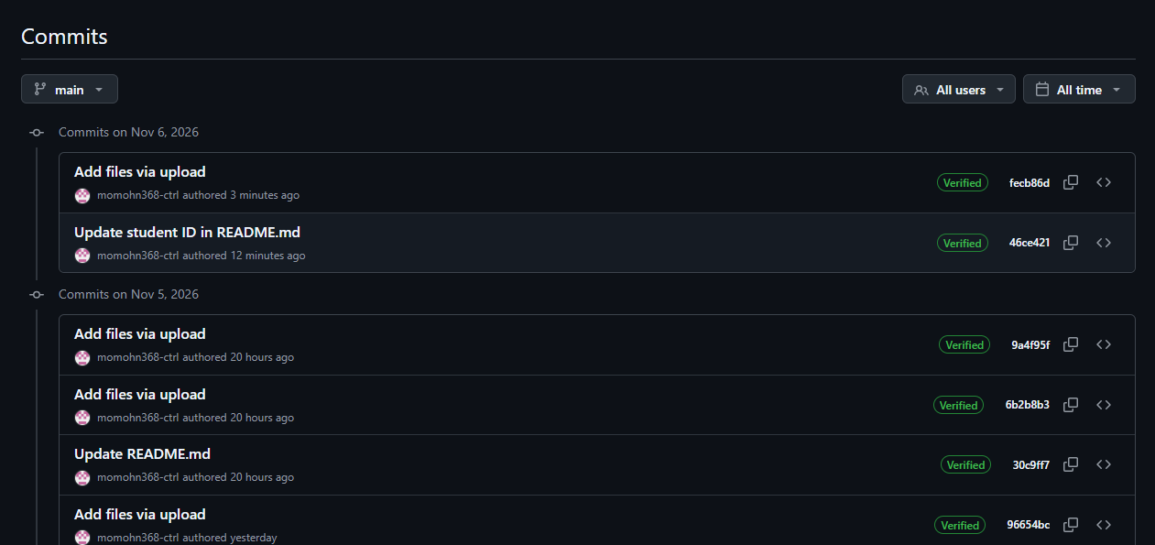

7.3 Repository Screenshot
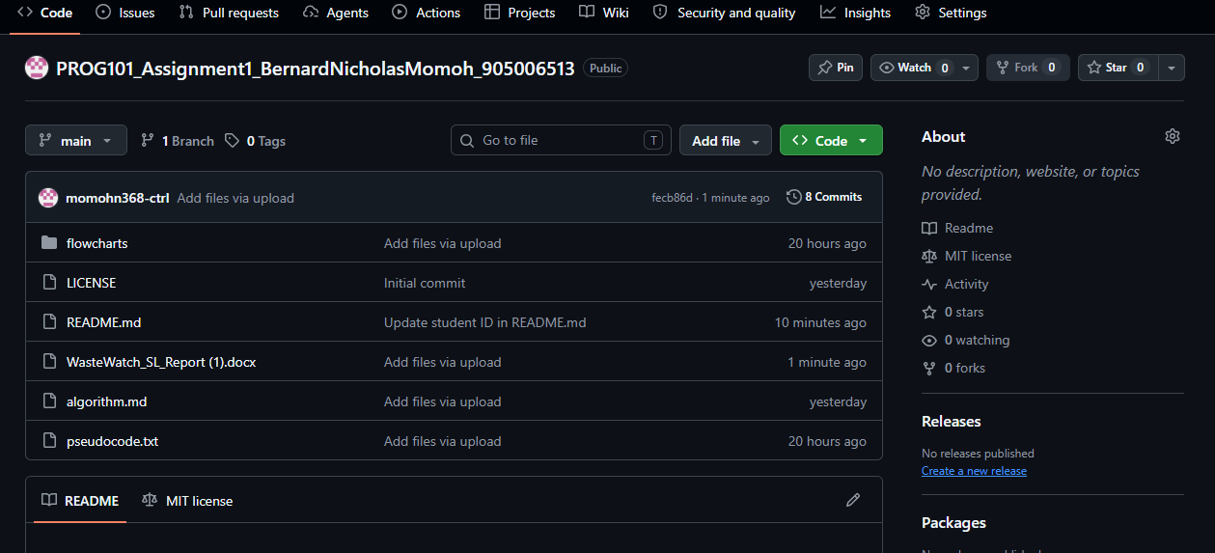

8. References
- ACAPS (2020) Anticipatory note: Sierra Leone – floods. Available at: https://www.acaps.org/sites/acaps/files/products/files/20203107_acaps_start_fund_anticipatory_note_sierra_leone_final_augt_4_2020.pdf.
- Concern Worldwide (2019) Sierra Leone's waste and flooding crisis. Available at: https://www.concern.net/news/sierra-leones-waste-and-flooding-crisis.
- COPIP (2021) Transform Freetown Solid Waste Management and Sanitation Project. Available at: https://copip.eu/news/transform-freetown-solid-waste-management-and-sanitation-project/.
- Digital Public Goods Alliance (2020) Why open source? Available at: https://www.digitalpublicgoods.net/blog/why-open-source Digital Public Goods Alliance (n.d.) Digital Public Goods Standard. Available at: https://digitalpublicgoods.net/standard.
- Interoperable Europe (2020) Digital Public Good – a global standard for governmental open source. European Commission. Available at: https://interoperable-europe.ec.europa.eu/node/703724.

